TWO-STEP TELESCOPED PHOTOCATALYTIC MINISCI REACTION IN CONTINUOUS FLOW WITH THE PHOENIX FLOW REACTOR™ AND THE PHOTOCUBE™

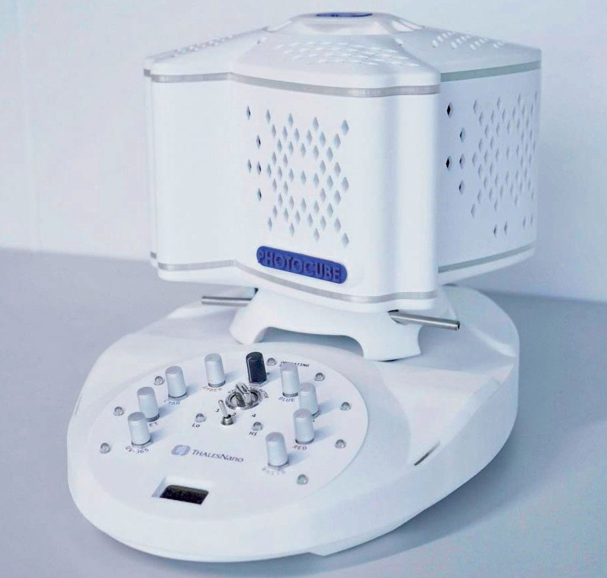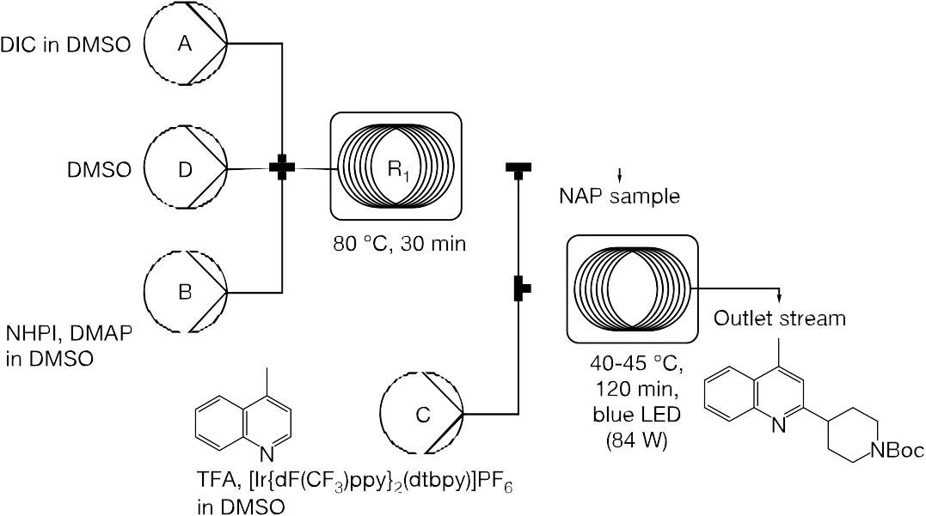Introduction
Photochemistry, especially the well-documented Minisci reaction offers a particularly useful approach to create new C(sp2)-C(sp3) bonds, however, traditional batch procedures often require long reaction times (27-44 hours).1-3

Continuous flow technology enables the acceleration of the reaction, furthermore, multiple synthetic steps can be merged in to one sequence with careful planning, resulting in higher yields4.

Considering such benefits, our aim was to decrease the reaction times and increase the yield of a two-step synthetic process, including the formation of a N-(acyloxy) phthalimide (NAP) intermediate and a Minisci reaction starting from lepidine (4-methylquinoline, Scheme 1.).

Scheme 1. Telescoped Minisci reaction performed with the PhotoCube™
(P1, P2, P4: Syringe pumps, P3: MicroHPLC pump, R1: Phoenix Flow Reactor™, R2: PhotoCube™

Instrumentation
For the NAP intermediate formation, a Phoenix Flow Reactor™ was used. The instrument is designed to perform a wide range of reactions up to 450 °C. The pressure range can extend up to 200 bar applying a back pressure regulator.

Photocatalytic experiments were performed with the PhotoCube™, a multifunctional photoreactor for batch and flow applications with 7 simultaneously available wavelengths (365, 395, 457, 500, 523, 595, 623 nm) and white light. Both batch and flow reactions can be performed within the same reaction chamber, using either vials or FEP/PFA tubing of different volumes. The reaction chamber temperature can range from 20 to 80 °C. Light
Experimental

Synthesis of N-BOC-4-(4-methylquinolin-2-yl) piperidine (Table 1. Entry 2)

Preparation of the reagent solutions
Feed A: DIC (1,3-diisopropylcarbodiimide, 465 µL,
3.00 mmol, 5.0 equiv.) and DMSO (5.0 mL) were added to and mixed in a 30 mL screw cap vial. A syringe was charged with this stock solution.
Feed B: 1-[(tert-butoxy)carbonyl]piperidine-4-car- boxylic acid (688 mg, 3.00 mmol, 5.0 equiv.), NHPI
(N-hydroxyphthalimide, 489.6 mg, 3.00 mmol, 5.0 equiv.), DMAP (4-(dimethylamino)pyridine, 12.2 mg,
0.1 mmol, 0.167 equiv.) and DMSO (5.0 mL) were added to and mixed in a 30 mL screw cap vial. A syringe was charged with this stock solution.
Feed C: (Ir[dF(CF )ppy] (dtbpy))PF6 (3.4 mg, 3

intensity can be regulated for each wavelength
3
µmol, 0.005 equiv.),
2
lepidine (80 µL, 0.6 mmol, 1.0

independently and/or simultaneously, which provides
opportunity for reactions requiring multi-wavelength irradiation or multi-step applications5.

Syrris Asia and Aladdin 2000 syringe pumps, and a ThalesNano microHPLC pump were used for reagent delivery.

The applied system was set up according to Scheme
2. The tubes were washed with DMSO. Feed A, B and C were introduced by syringe pumps, while feed D was charged with a microHPLC pump. Feeds A, B and D were connected by a cross mixer. The outlet of the mixer was introduced into the first reactor (4 or 16 mL heated stainless-steel tube). The existing reaction stream was connected to another cross mixer, where feed C was introduced. This mixer had two outlets: one for occasional sampling of the intermediate and the other was connected to the loop (20 mL, 3-layered, FEP) of the PhotoCube™.

Aside from the stainless-steel coil of first reactor, 1 mm ID FEP tubes were used to assemble the system.

Risk assessment and hazards: Always use these systems in well-ventilated fume hoods to avoid inhalation of solvent vapours. Never open them at high pressure or temperature, the overheated
equiv.), TFA (46 µL, 0.6 mmol, 1.0 equiv.) and DMSO
(1.0 mL) were added to and mixed in a 4 mL screw cap vial. A syringe was charged with this stock solution.

Setting up and performing the reaction
The stainless-steel coil (4 mL) of the Phoenix Flow Reactor™ was heated up to 80 °C and the Photo- Cube™ was switched on (blue LEDs, 4 panels, high mode). The tubing of each feed was filled up with the respective solution to the cross mixers. Then, flow rates (0.067 mL/min for feed A and B, and 0.033 mL/ min for feed C) and the volumes to be delivered (2.5 mL for feed A and B, and 0.5 mL for feed C) were set on the pumps, which were started for feeds A and B. The flow rate of the microHPLC pump was set to 0.133 mL/min. Once the injection period ended, the syringe pumps were switched off and microHPLC pump was turned on to deliver DMSO. Residence time in the first reactor was 30 min. When the feed of NAP intermediate reached the cross mixer, the pump for feed C was started.

When its injection period ended, the syringe pump was stopped and the microHPLC pump was set to
0.166 mL/min to deliver the second reaction, with 2 h residence time. The reaction mixture collected from the output was diluted with DCM and washed with 25 % NH3 solution. The aqueous phase was extracted with DCM, then the combined organic phase was
washed with H O and brine. The solution was dried
2

or pressurized solvents can cause injuries. Avoid
contact with the heated parts.
over Na SO
2
and
4
concentrated in vacuo.

Purification of the crude product was performed by flash chromatography on silica gel using cyclohe- xane/ethyl-acetate (10 to 15% ethyl acetate) mixture as eluent, and then purified again on silica gel using cyclohexane/ethyl-acetate (0 to 10% ethyl acetate) mixture as eluent afforded the desired product (64 mg, 65%).

1H NMR (300 MHz, CDCl ) δ 8.03 (d, J = 8.4 Hz, 1H),
Entry | Starting material | Yield obtained | Yield (from literature)
1 |  | 81-92% | 83%
2 |  | 65% | 62%
3 |  | 88% | 88%

3
7.95 (d, J = 8.3 Hz, 1H), 7.68 (ddd, J = 8.3, 7.0, 1.3 Hz,
1H), 7.51 (ddd, J = 8.1, 6.9, 1.2 Hz, 1H), 7.15 (s, 1H), 4.28
(br s, 2H), 3.02 (tt, J = 11.9, 3.8 Hz, 1H), 2.95 – 2.79 (br
m, 2H), 2.69 (s, 3H), 1.97 (br d, J = 12.2 Hz, 2H), 1.91 – 1.74 (m, 2H), 1.49 (s, 9H).

13C NMR (75 MHz, CDCl ) δ 164.46, 154.99, 147.77,
3
144.84, 129.64, 129.32, 127.27, 125.84, 123.77, 120.16,
79.57, 45.65, 44.39 (br), 31.75, 28.65, 19.01.

MS APCI (m/z): 327.4

Results and discussion
After optimization, 30 min residence time was chosen for the NAP intermediate formation, while the Minisci-reaction was performed with 30 min or 2 h residence time depending on the substrate of choice. To maximize the throughput a 20 mL reactor coil was used for all photochemical reactions. Consequently, the flow rates and the appropriate coil size for the Phoenix Flow Reactor™ was chosen accordingly.

Precise knowledge of the dead volumes and residence time distribution in each system component allows the user for precise timing of reagent feeds and therefore to avoid the loss of material. This is especially important when working with small amounts of samples (i.e., volume of reaction solution << volume of reactor). We used UV spectroscopy to measure these parameters and to trigger product collection. Alternatively, a dye might be used for dead volume measurement. Please note however, that gas formation occurs during the Minisci reaction and might affect the residence time.

Using this protocol, a series of compounds were successfully synthesized and obtained with good overall yields after purification by column chromatography. Table 1. contains a few selected examples, in comparison with the literature data. 4 In all cases, continuous flow experiments using the PhotoCube™ resulted in similar yields as reported before, but a significant decrease in reaction times was achieved.

Table 1. Comparison of yields obtained in continuous flow (with the PhotoCube™) with the literature data4

A scale-out experiment between lepidine and cyclohexane carboxylic acid was successfully performed on 6 mmol scale indicating that a 1.2-1.3 g/h throughput can be achieved during continuous production. This flow process (including heating up and washing time periods) was performed within 3 hours, while the two-step batch procedure would take around 27 hours.

In conclusion, we developed an NAP-intermediate formation - Minisci reaction sequence which showed promising results. Practically useful throughputs and convenient process times were reached.

Acknowledgement
This study was undertaken in the laboratories of ComInnex Inc. and ThalesNano Inc.

References
1 M. H. Shaw, J. Twilton, and D. W. C. MacMillan J. Org. Chem. 2016, 81, 6898-6926. 2 (a) R. S. J. Proctor and
R. J. Phipps Angew. Chem. Int. Ed. 2019, DOI: 10.1002/ anie.201900977. (b) M. A. J. Duncton Med. Chem. Commun. 2011, 2, 1135-1161. 3 T. C. Sherwood, N. Li,
A. N. Yazdani, T. G. M. Dhar J. Org. Chem. 2018, 83, 3000-3012. 4 T. Plutschack, B. Pieber, K. Gilmore, P. H. Seeberger Chem. Rev. 2017, 117, 18, 11796–11893
5 D. Rombach, H.-A. Wagenknecht ChemPhotoChem
2018, 10, 2955-2961.

AND SO MUCH MORE TO DISCOVER…

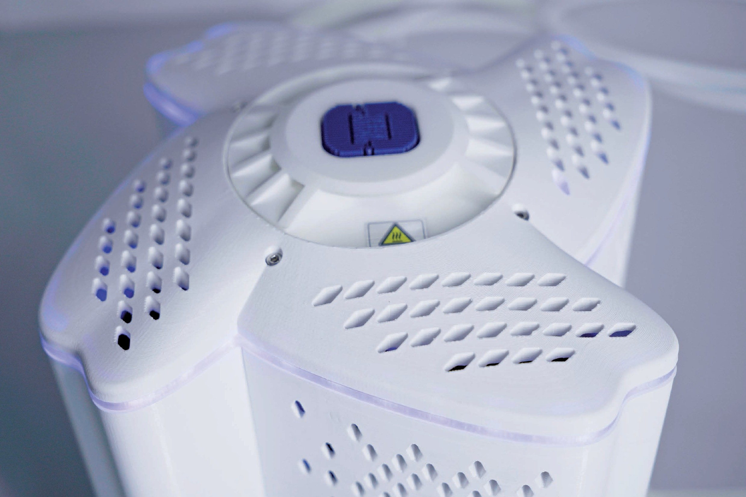For more information, please visit
www.thalesnano.com
Linkedin: /company/thalesnano-inc- Twitter: /thales_nano
Instagram: /thalesnano_inc/ Facebook: /ThalesNano/
ThalesNano Inc.
Záhony utca 7. | H-1031 Budapest | Hungary
Phone: +36 1 880 8500
Fax: +36 1 880 8500
Email: sales@thalesnano.com www.thalesnano.com
US Office
50 S. Penn St. Suite B-2 Hatboro PA. 19040 USA
Phone: 215-534-3365
E-mail: USAsales@thalesnano.com

